**Student Information Management System**

1. Initialization interface displaying student information with a bottom panel for add a new student information;

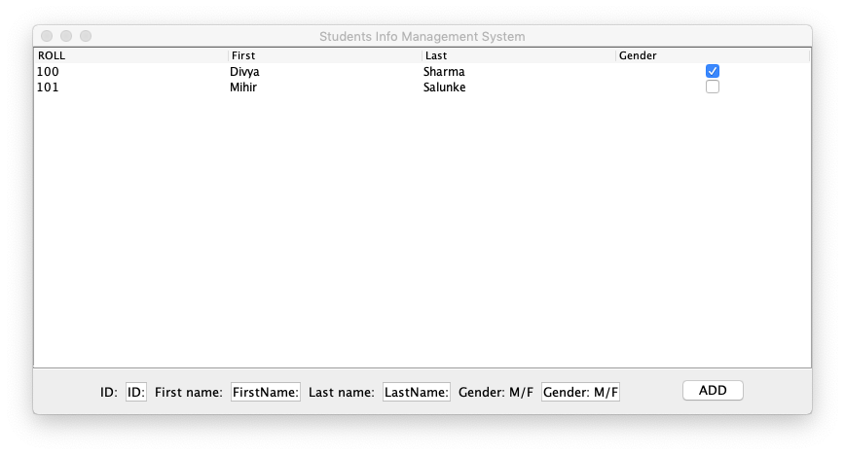

1. Input the student id, name, gender. About gender, you can only input M or F which represents male or female. Then click “ADD” button;

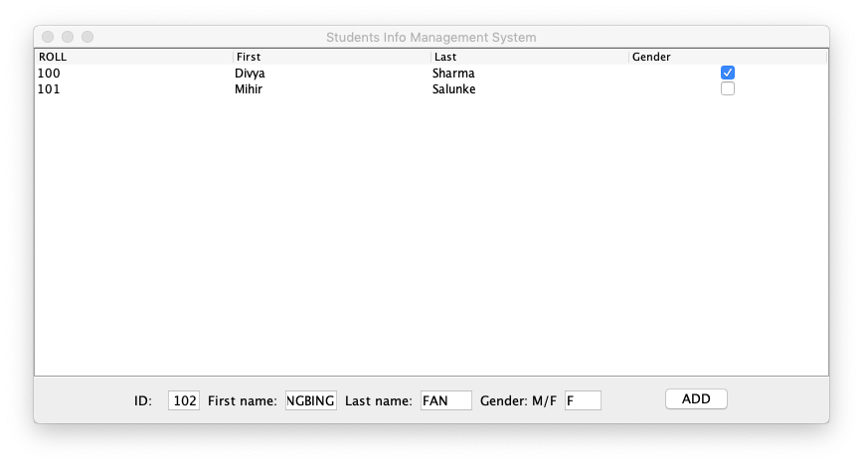

1. Student table will update with the change. The new student information will display on screen

